E-Read Texas website text
February 2026

About this document
This document contains suggested text to use on your library website. Feel free to make edits as you feel appropriate. TSLAC recommends linking the CloudLibrary logo to your library’s site-specific URL, or the generic site https://yourcloudlibrary.com/.

Logo image files
Download the E-Read Texas and CloudLibrary logos from https://www.tsl.texas.gov/ldn/ebooks/promotion

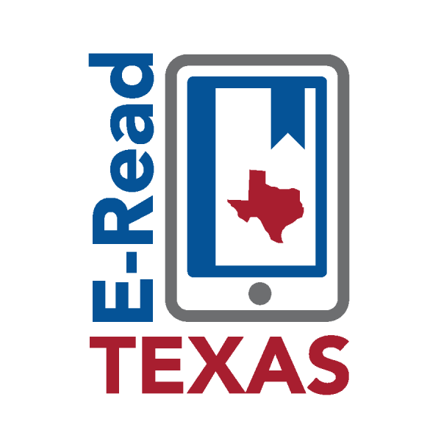
E-Read Texas provides approximately 20,000 e-books and audiobooks to eligible public libraries in Texas. The collection contains popular adult fiction and non-fiction, as well as some young adult crossover materials. You’ll find newly published titles from well-known authors, as well as classics and independent fiction. There’s also a great selection of nonfiction titles to help you learn new things, such as languages, arts and crafts, gardening, or business skills.

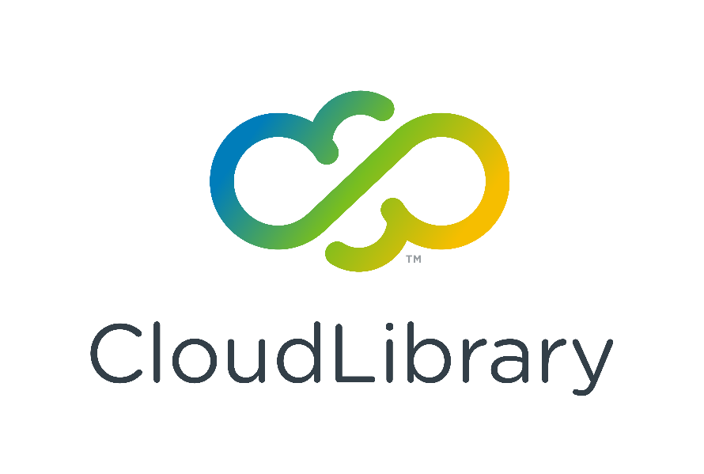
Titles can be accessed through the CloudLibrary app, which is available for Apple, Android, and Kindle Fire devices. Please contact us if you have any questions about using CloudLibrary.

